**Ideation Phase**

**Define the Problem Statements**

|  |  |
| --- | --- |
| Date | 22 June 2024 |
| Team ID | SWTID1719939027 |
| Project Name | Book Nest |
| Maximum Marks | 3 Marks |

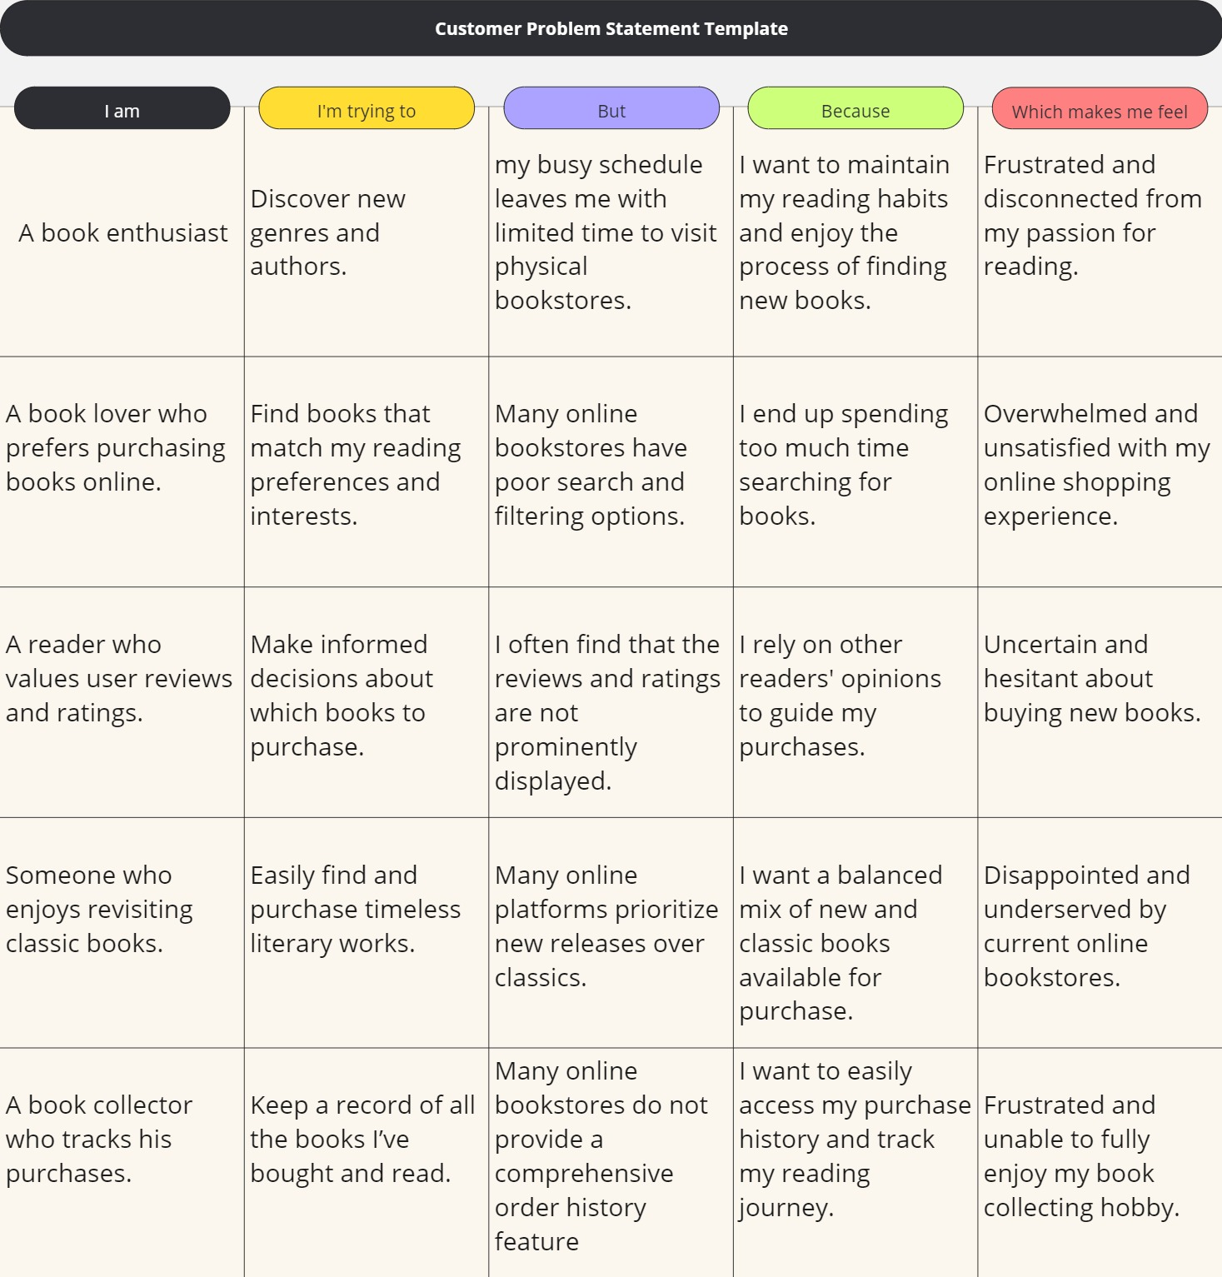

|  |  |  |  |  |  |
| --- | --- | --- | --- | --- | --- |
| **Problem Statement (PS)** | **I am (Customer)** | **I’m trying to** | **But** | **Because** | **Which makes me feel** |
| PS-1 | A book enthusiast | discover new genres and authors | my busy schedule leaves me with limited time to visit physical bookstores | I want to maintain my reading habits and enjoy the process of finding new books | frustrated and disconnected from my passion for reading |
| PS-2 | A book lover who prefers purchasing books online | find books that match my reading preferences and interests | many online bookstores have poor search and filtering options | I end up spending too much time searching for books | overwhelmed and unsatisfied with my online shopping experience |
| PS-3 | Who values user reviews and ratings | make informed decisions about which books to purchase | I often find that the reviews and ratings are not prominently displayed | I rely on other readers' opinions to guide my purchases | uncertain and hesitant about buying new books |
| PS-4 | Who enjoys revisiting classic books | easily find and purchase timeless literary works | many online platforms prioritize new releases over classics | I want a balanced mix of new and classic books available for purchase | disappointed and underserved by current online bookstores |
| PS-5 | The book collector who tracks his purchases | keep a record of all the books I’ve bought and read | many online bookstores do not provide a comprehensive order history feature | I want to easily access my purchase history and track my reading journey | frustrated and unable to fully enjoy my book collecting hobby |